Measurement and Proof Test Review Name: _______________________pd: ___

**Define the following:**

|  |  |
| --- | --- |
| Segment Addition Postulate |  |
| Midpoint |  |
| Angle Addition Postulate |  |
| Bisector |  |
| Supplementary angles |  |
| Complementary angles |  |
| Vertical angles  (draw a picture) |  |
| Adjacent angles |  |
| Linear Pair  (draw a picture) |  |
| Distance |  |
| Substitution Property |  |
| Reflexive Property |  |
| Symmetric Property |  |
| Transitive Property |  |
| Distributive Property |  |
| Definition of Congruency |  |

**Use the picture for problems 1-10 identify the relationships below:**

**1**

**2**

**3**

**4**

**5**

**6**

$∠1≅∠$

$m∠6=m∠$ $+ m∠$ $+ m∠$

$m∠$ $+ m∠$ $=90°$

$m∠$ $+ m∠$ $=180°$

1. $∠2$_______
2. _______ _______ _______
3. ______ ______
4. ______ ______
5. and $∠3$ are _________________________.
6. $∠1$ and $∠6$ are _________________________.

**If $m∠2=60°$ and $m∠5=50°$, fill out the measures of the remaining angles.**

$m∠1=$

$m∠3=$

$m∠4=$

$m∠6=$

1. ____________
2. ____________
3. ____________
4. ____________

**11.) $∠WXY$** and $∠YXZ$ are complementary angles. $m∠WXY=\left(5x-18\right)°$ and $m∠YXZ=(2x+3)°$. Find the measures of both angles.

**12.) $\vec{AT}$** bisects $∠MAH$. $m∠MAH=\left(3x-31\right)°$ and $m∠TAH=\left(2x-5\right)°$. Find $m∠MAT, m∠TAH,$ and $m∠MAH$.

**13.)** What is the midpoint of $\overline{AB}$ if $A$ has coordinates $(-5, 8)$ and $B$ has coordinates $(7, 10)$?

**14.) $\overline{PS}$** has a midpoint $Q(3, 5)$. What are the coordinates of $P$ if $S$ has coordinates of $(1, -5)$?

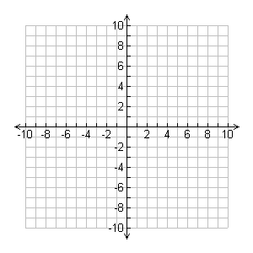

$$W$$

$Y$ Y

**15.)** Find $WY$.

**16.)** Find the midpoint of $\overline{WY}$.

**17.)** Find the distance between $A(-5, 2)$ and $B(7, 13)$. Round to the nearest tenth if necessary.

**18.) $\overline{CD}$** has endpoints $C\left(3, 9\right)$ and $D\left(5, 11\right).$ Find $CM$, where $M$ is the midpoint of $\overline{CD}$.

**19.)** Mr. Toto needs to cross a square field that is **200** meters long on each side. In the field is a bull, a very angry bull that does not want to share his field with Mr. Toto. The gate that Mr. Toto would go through to get into the field is **50** meters from point **A** of the field. He needs to get to the gate at point **D**, which is across the field. The bull is standing at point **B**, pawing the ground and snorting loudly. Once Mr. Toto enters the field and starts running to the other gate, the bull takes off and heads for the same gate in order to get Mr. Toto.

**a.)** How far does Mr. Toto have to run to get to the other gate?



A

B

C

D



**b.)** How far does the bull have to run to get to the same gate?

**c.)** Mr. Toto’s sense of impending doom is making him run as fast as he possibly can, which is 10 meters per second. The bull is charging the gate at 14.5 meters per second. Does Mr. Toto make it to the gate first?

**20.)** John is working on a project. For this project, he has to **tri-sect** (or split into three equal parts) the segment $\overline{GH}$, then find the midpoints of each smaller segment. What are the coordinates of each midpoint?

G

H

-4

8

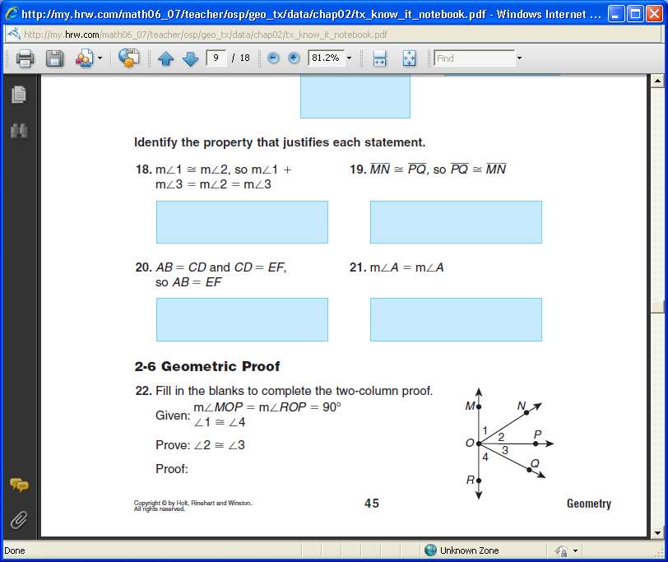**Fill in the blanks to complete the proof:**

Given: $m∠MOP=m∠ROP=90°;∠1≅∠4$

Prove: $m∠2=m∠3$

|  |  |
| --- | --- |
| Statements | Reasons |
| 1 | 1 Given |
| 2 m∠1 = m∠4 | 2 |
| 3 m∠1 + m∠2 = m∠MOP  m∠3 + m∠4 = m∠ROP | 3 |
| 4 m∠3 + m∠4 = m∠MOP | 4 |
| 5 m∠1 + m∠2 = m∠3 + m∠4 | 5 |
| 6 m∠1 + m∠2 = m∠3 + m∠1 | 6 |
| 7 | 7 Reflexive Prop = |
| 8 | 8 Subtraction Prop = |

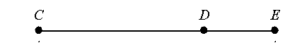

8x

3x -12

42

Given:

Prove: $x=6$

|  |  |
| --- | --- |
| Statements | Reasons |
| 1 CD = 3x-12; DE = 42, CE = 8x | 1 Given |
| 2 | 2 Segment Addition Post. |
| 3 8x = 3x-12 + 42 | 3 |
| 4 | 4 |
| 5 | 5 |
| 6 | 6 |
| 7 | 7 |
| 8 | 8 |