Name________________________ Period_______

**Geometry Review for Final - Fall 2017**

For the given figure, find the value of x and the measure of angle 1.



1





1



1. 2.

3. Find the lengths of segments AB and BC in the given situation.



A

B

C

4. Solve:  bisects , and

. Solve for x and find .

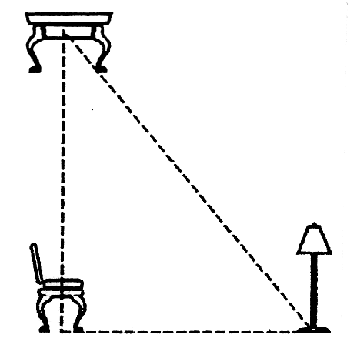5. A stage is set according to the following specifications. A chair is placed at point A, a table at point B, and the lamp at point C. If the distance from A to B is 8 feet and the distance from A to C is 7 feet, what is the distance from the table (point B) to the lamp (point C)?

6. Consider the pattern of numbers shown below.

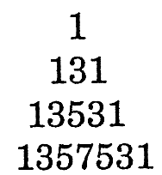

Use inductive reasoning to determine the next line in the pattern.

Use the diagram to answer questions 7 - 16. Tell the relationship of angles:

10

2

11

9

1

C

A

B

14

12

4

3

13

F

6

20

19

16

15

5

H

E

D

22

21

18

17

8

7

G

1. linear pair
2. acute angle
3. obtuse angle
4. corresponding angles
5. supplementary angles
6. right angle
7. vertical angles
8. perpendicular lines
9. collinear points
10. ray
11. parallel lines
12. complementary angles
13. alternate interior angles
14. same side interior angles
15. no relationship

7. 

8. and <14 + <13

9.  and 

10. A, B, and C

11.  and 

12.  and 

13.  and 

14.  and 

15.  and 

16.  and 

Identify which property makes the following statements true:

(a) Reflexive (b) Symmetric (c) Transitive (d) Segment Addition property

17. If x + 12 = 17 and since y = 17, then x + 12 = y.

18. If A, B, and C are consecutive points on a line, then AB + BC = AC

19. If WS = NL, then NL = WS

20. If 4 = 4, then 4 = 4.

Tell whether the following is the inverse, converse, contrapositive, or none for the following statement:

“If a figure is a parallelogram, then opposite sides are parallel.”

(a) inverse (b) converse (c) contrapositive (d) none of the above

21. If opposite sides are not parallel, then the figure is not a parallelogram

22. If a figure is not a parallelogram, then opposite sides are not parallel.

23. If opposite sides are parallel, then the figure is not a parallelogram

24. If opposite sides are parallel, then the figure is a parallelogram.

**Use correct notation to name the following.**

B

A

C

25. _________



26. _________



27. _________

**Sketch an example of each of the following.**

28. noncollinear points *D, E, F* in a plane *W*

29.  in plane *A*

30.  and  intersect in point *C*

31. Find the measure of the complement of ∠F, where m∠F = 78.9°

32. An angle measure is 3 degrees more than 2 times its supplement. Find the measure of its supplement.

*[Hint: If the angle is x, then its supplement is (180 – x)]*

33. _______________________________Write an equation in point-slope form for the perpendicular bisector of the segment with endpoints *X*(3, -1) and *Y*(5, 7).

**KNOW THE FOLLOWING TERMS:**

***Perpendicular Bisector-***

***Angle Bisector -***

***Median-***

***Altitudes-***

35. Find DC. 36. Find BC. 37. Find LM.

 __________ ____________________

1. What is the slope of the function 9*x - 3y* = 24? (hint: write in slope-intercept form)

39..What is the apparent slope of the line graphed below and a point on the graph?



**M = ___________**

Point: ( , )

40. A figure is translated . What translation would move the image

back to its original position?

41-43: Matching. Some answered may be used more than once

|  |  |  |  |  |  |  |  |
| --- | --- | --- | --- | --- | --- | --- | --- |
| **A** | Translation | **b** | Rotation | **C** | reflection | **d** | dilation |

|  |
| --- |
| 41. a transformation that slides each point of a figure the same distance in the same direction |
| 42. a transformation that spins each point of a figure around a central point. |
| 43. a transformation in which each point of a figure is flipped across a line to form the image |

44. Which kind of transformation is shown in the figure?

5

4

3

2

1

-1

-2

-3

-4

-6

-4

-2

2

4

6

B’'

B’

**45-49: Use the figure below to answer the following questions**.

 45. Name an angle bisector shown in Δ*ABC*. ______

46. Name a median shown in Δ*ABC*. ______

47. Name an altitude shown in Δ*ABC*. ______

48. If *EB* = 12.5 cm, find *AB*. ______

49. If *m*∠*ABD* = 34.3o, find *m*∠*ABC*. ______

50. Find the value of *x*.



1. If a line contains the points (1, -2) and (3, 2), which of the following points is collinear with the two points? (Graph it!)

|  |  |
| --- | --- |
| A. | (-4, -2) |
| B. | (5, 6) |
| C. | (2,1) |
| D. | (6, 5) |

1. Determine whether the pair of lines -x + 2y = 6 and y = 2x + 3 are parallel, perpendicular, or neither.

a. Parallel b. Perpendicular c. Neither

1. A line is has the following equation: 2x - 4y = 6 . What is the slope of the line perpendicular to it?

a. -1/2 b. 1/2 c. -2 d. 2

1. What relationship between the slopes of two lines is needed to show that the lines are perpendicular?
   1. There is no general rule as the y-intercept is different
   2. One slope is negative and the other is positive
   3. They have the same slope
   4. One slope is the opposite reciprocal of the other
2. Using the figure to the right, what is the value of x?

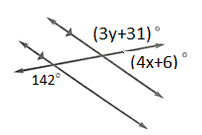

a.6 b. 8 c. 34 d. 38

1. What is the value of y?

a.37 b. 142 c. 25 d. $\frac{7}{3}$

1. Determine if the figure below has reflection symmetry, rotational symmetry, both of these, or neither of these.

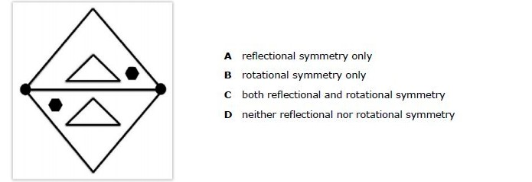

1. 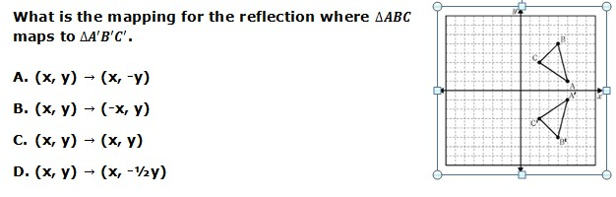

*Define the following terms:*

1. Segment Addition Postulate
2. Angle Addition Postulate
3. Transitive Property
4. Substitution Property
5. Definition of Complementary Angles
6. Definition of Right Angles
7. Definition of Midpoint
8. Definition of Bisector
9. Theorem
10. Inductive Reasoning
11. Deductive Reasoning
12. Counterexample
13. Postulate
14. Collinear
15. Coplanar
16. Bisect
17. Equidistant
18. Congruent
19. Perpendicular Bisector
20. Parallel slopes
21. Perpendicular slopes
22. Transformation
23. Rotation
24. Reflection
25. Translation
26. Distance
27. Slope