- Find the area of the rectangle.
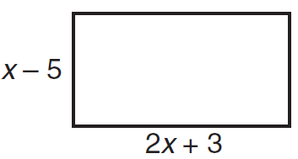

- Find the area of the parallelogram.
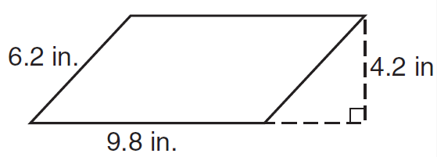

- Find the values of x when A=240 ft.²
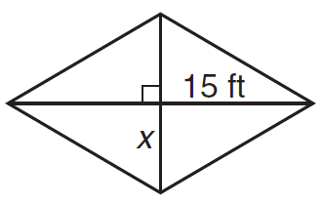

- Find the height of the trapezoid with A = 110.5 m.²
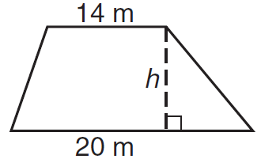

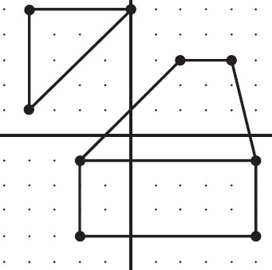
- The geoboard shows a rectangle, trapezoid, and a triangle. Find the area and perimeter of each figure.

5a) rectangle perimeter:

rectangle area:

5b) trapezoid perimeter:

trapezoid area:

5c) triangle perimeter:

triangle area:

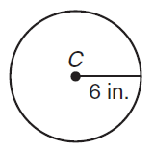
- Find the circumference of circle C in terms of pi.

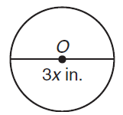
- Find the area of circle O in terms of pi.

- Find the area of a regular pentagon with perimeter 75 cm. Round to the nearest tenth.

- Find the area of a regular octagon with apothem 8 in. Round to the nearest tenth.

  - Find the shaded areas. Round to the nearest tenth, if necessary
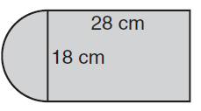
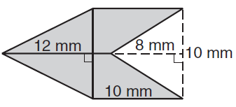

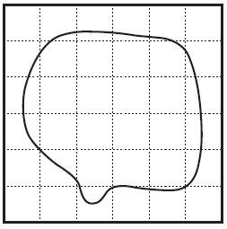
12. A map of an irregularly shaped pond is shown on the grid. The grid has squares with lengths of 1 yd. A clarifying chemical is added to the pond, based on the area of the pond. The chemical costs $13.88 per square yard. Find the total cost of applying the clarifying chemical to the pond.

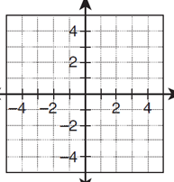
13. Draw and classify the polygon with the given vertices. Find the perimeter AND area of the polygon with vertices A(-2, 1), B(5, 1), C(-2, -4).

14. Draw and classify the polygon with the given vertices. Find the perimeter AND area of the polygon with vertices D(-2, 3), E(6, 3), F(6, -3), G(-2, -3).
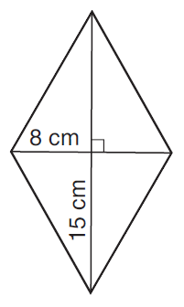
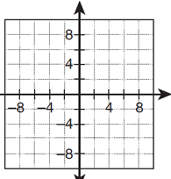
15. A pizza shop specializes in two sizes of pizza, the regular and the extra large. The regular has a 16-in diameter and requires 4 cups of dough. The diameter of the extra large pizza is 20 inches. About how much dough is needed to make an extra large pizza?

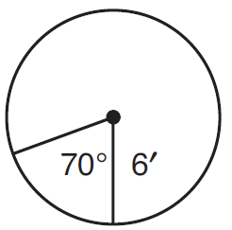
16. As part of a parks beautification committee Kelly is designing a circular flower garden. She plans to divide the flower garden into sectors and plant different colored flowers in each sector. What is the area of the sector to the nearest square foot?

17. Find each arc length. Give your answer in terms of p, rounded to the nearest hundredth, AND in radians.(You should have three answers for problems a) and b))
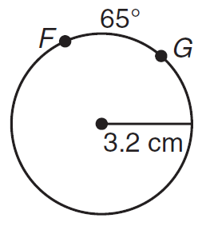
a) 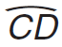 b) 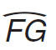
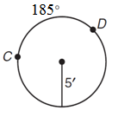

18. Convert the following degrees to radians… or radians to degrees:
a. 90º = ________ b. $\frac{2π}{3}$ = ________ c. 270º = ________ d. 2π = ______

Use the figures below to answer questions #19 – 24
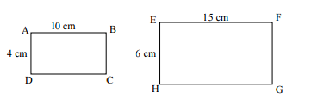

19. Find the scale factor of the sides. (EFGH / ABCD)

20. Find the perimeter of ABCD

21. Find the perimeter of EFGH

22. Find the area of ABCD

23. Find the area of EFGH

24. How does the scale factor of the sides compare to the scale factor of the area?

